**Patient_medicine-Appointment management System**

It is for Building a Patient Medicine and Appointment System App with SpringBoot and Thymeleaf.

**Features:**

Security login/register

Patient-Registration

Book-Appointments

Add TimeSlot for New Appointments Automatic updation

Add Prescription

View Prescription

Edit/Update Prescription

Delete Prescription

Manage Doctors

Dashboard

Unit Test Cases for Appointment Service-passed 6/6.

Exeption Handling

**Pre-requisite:**

->Springboot Web

->thymeleaf

->validation

->Lombok

->spring-boot-startet-Data-Jpa

->Security

->Mysql-Connector

->Spring-boot-starter-test

->Mockito-core

->springdoc-openapi-starter-webmvc-ui

**->Login Form:**This is the login form of our Application.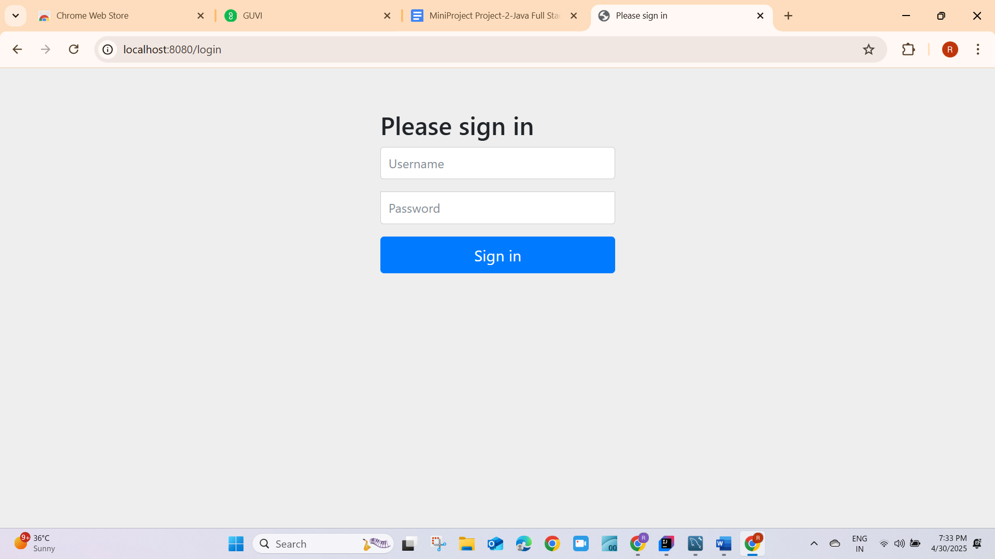

->**After giving registerd users like Authorized users(Spring Security) then it goes to dashboard.**

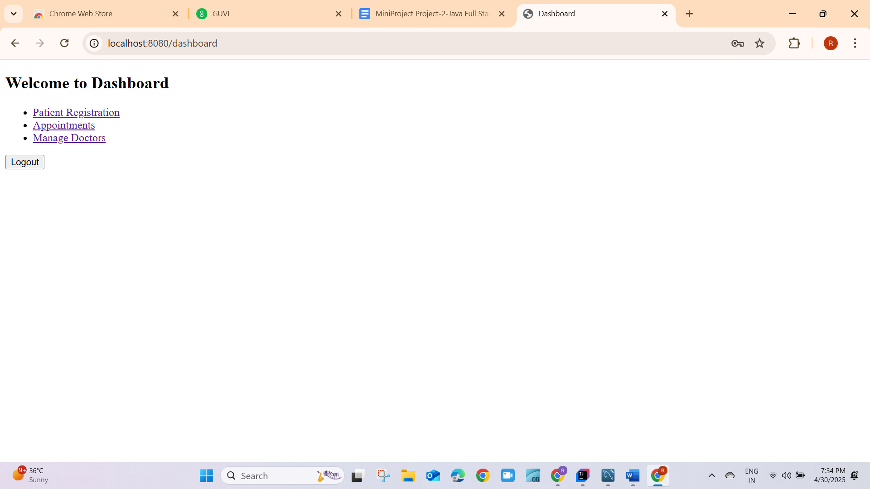

-After click on Patient registration for registering patients it will goes to Patient Registration form.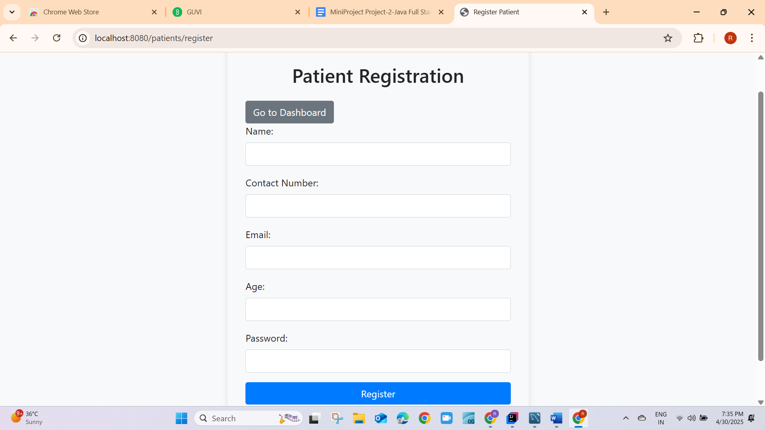

->After giving all fields then validate data then It gives Patient Registered Successfully message to the person.Then click on to Dashboard.

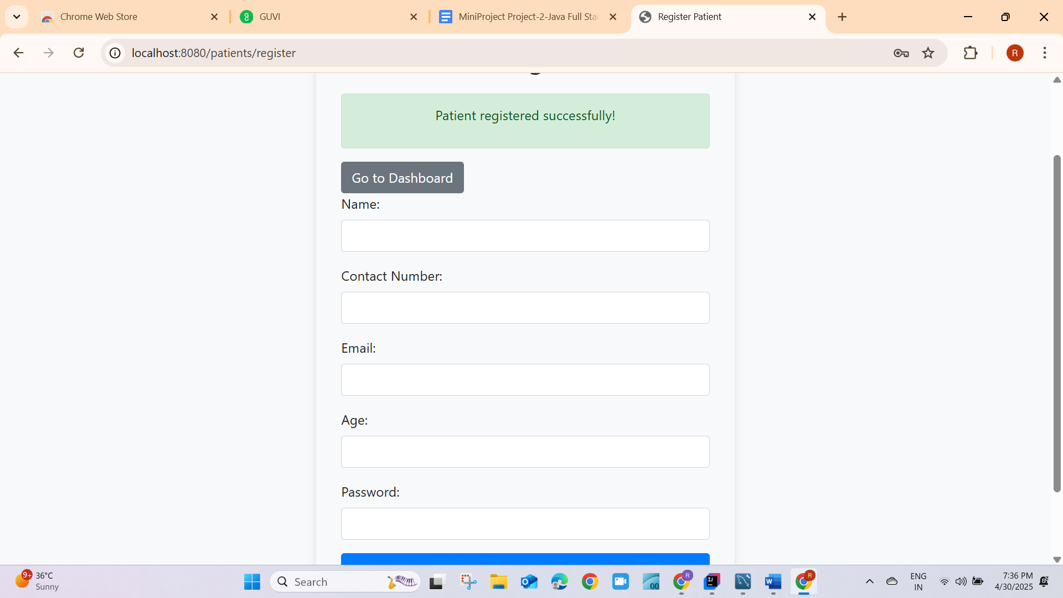

->dashboard->navigates to dashboard.

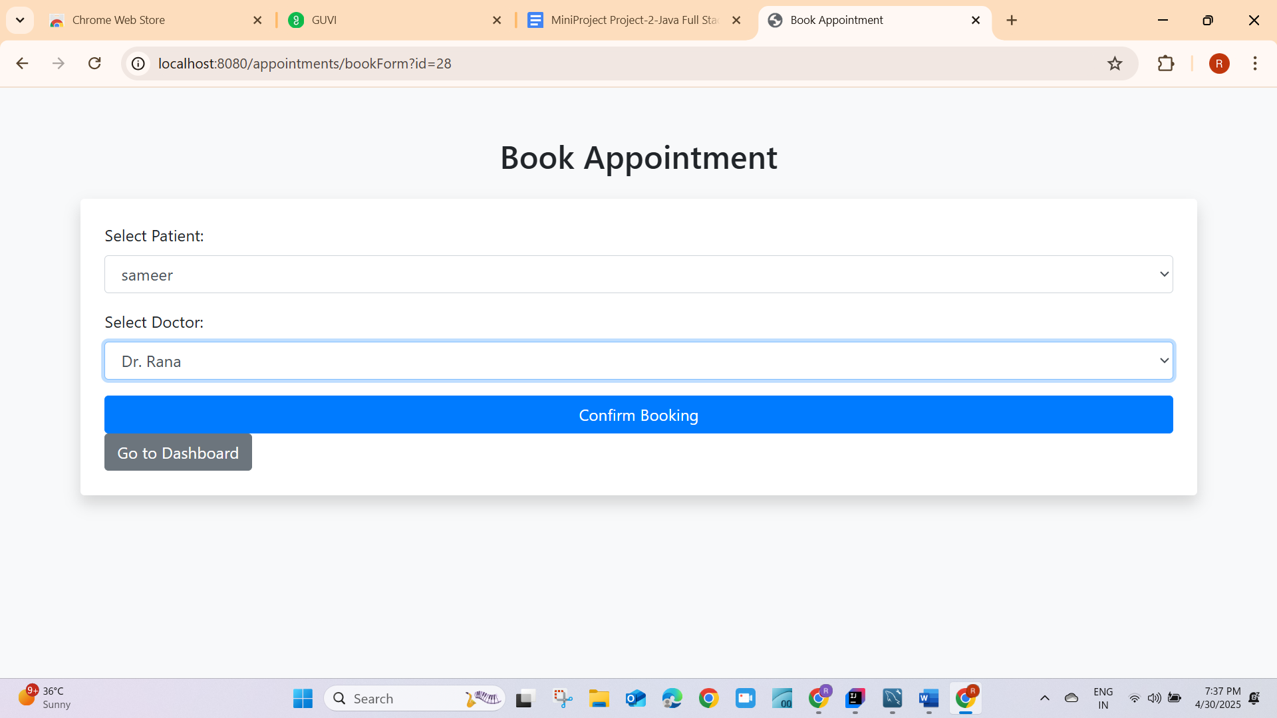

->Then click on Appointments it is redirected to book Appointment page then give patient name and Doctor.->click on Confirm booking->it will give success message of Appointment booked Successfully.

-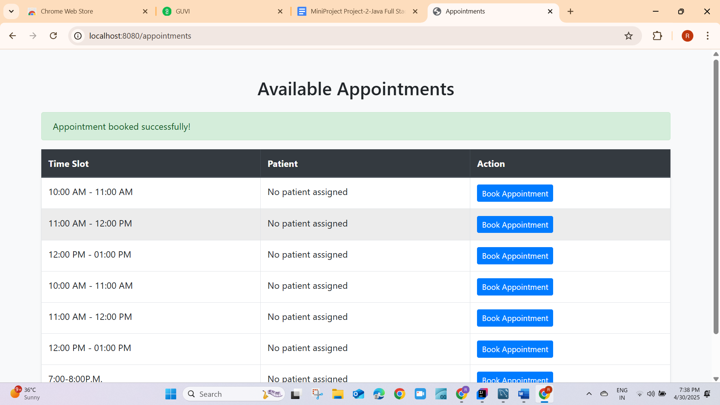

->now take backward arrow and go to dashboard.

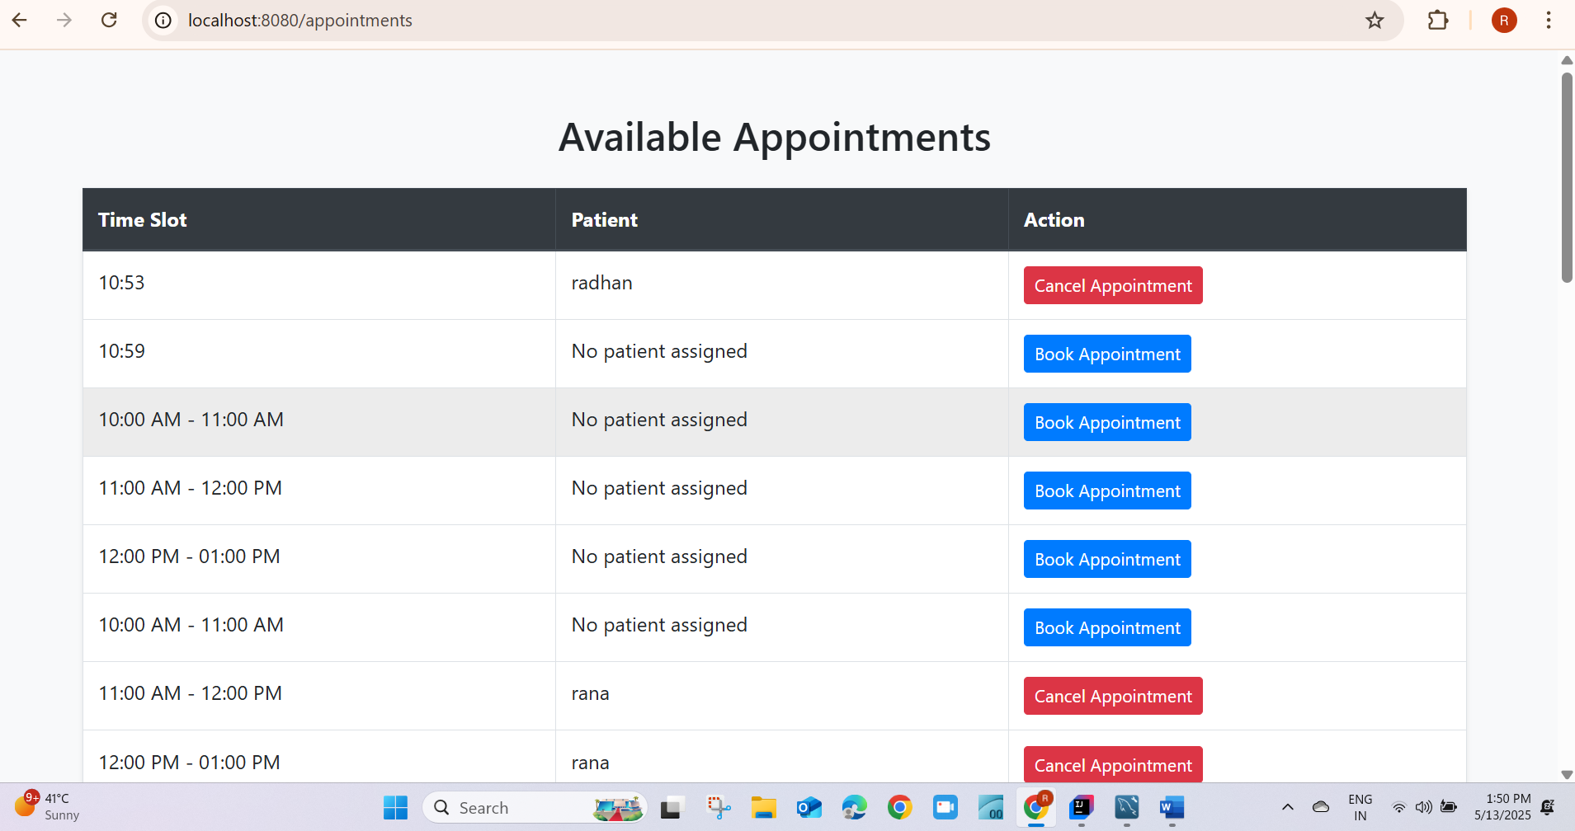

For if a patient/admin cancel the booked appointment then after booking it will show.

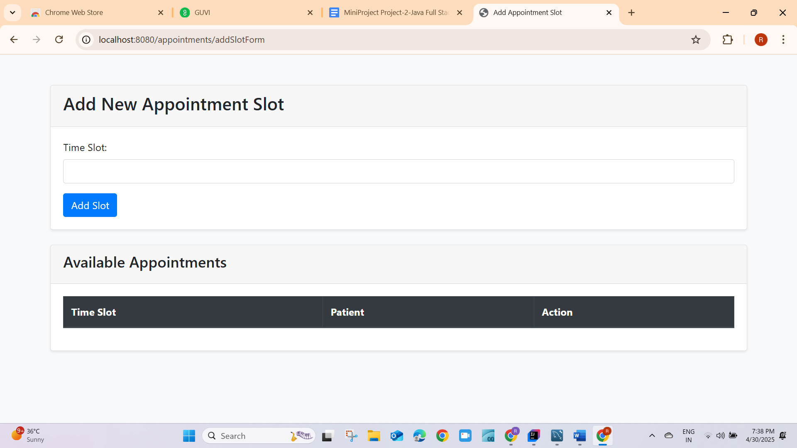

->click on Add Appointment Slot for adding empty slots for appointments booking.

-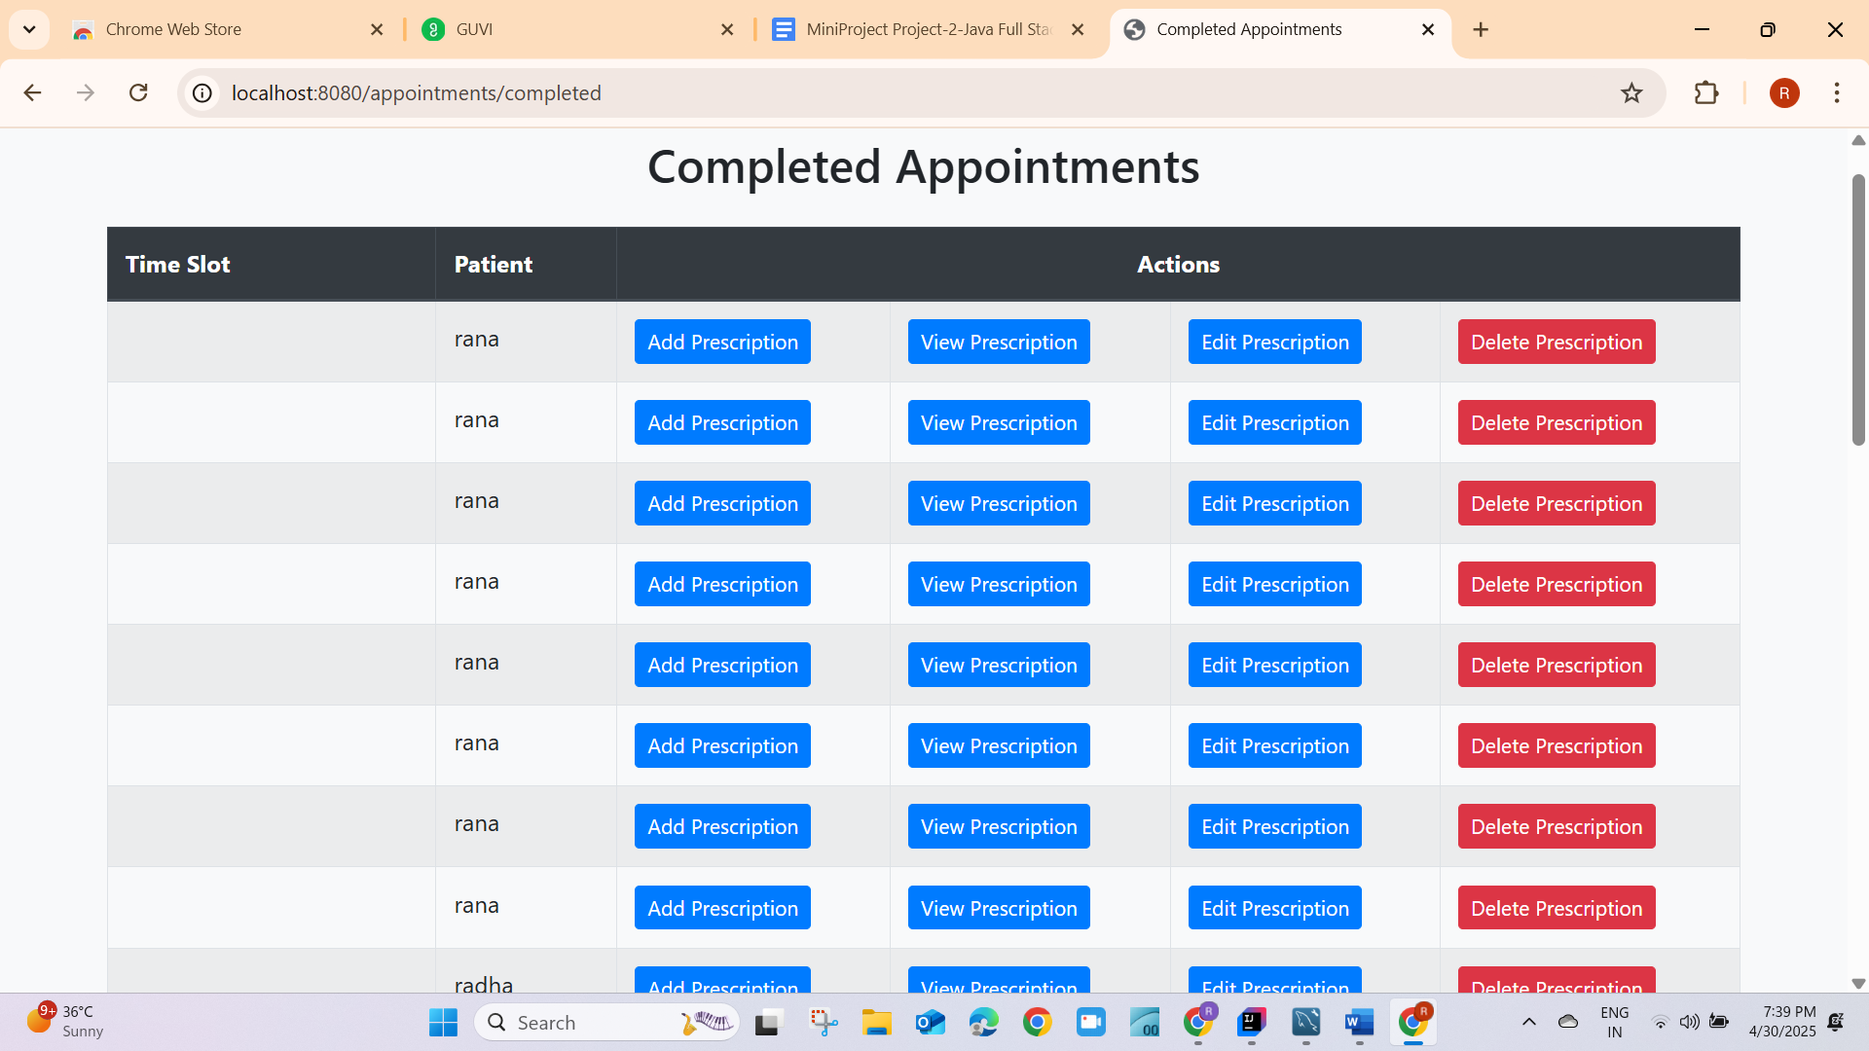

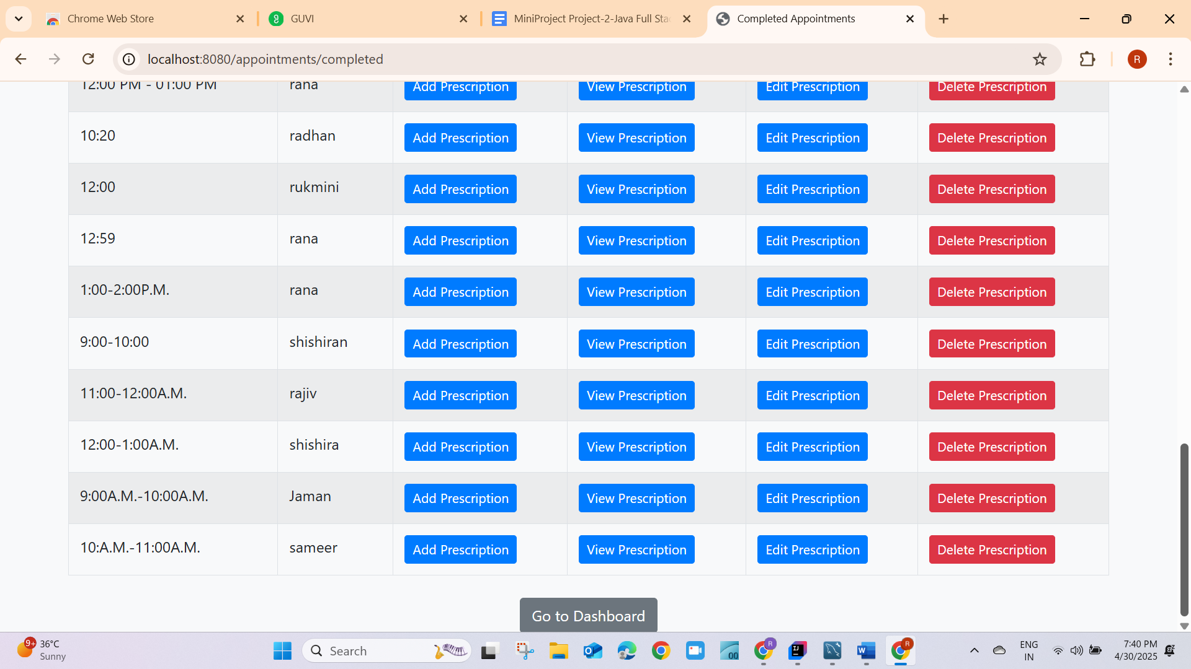

->After consulting the doctor it goes to Completed Appointments->then Add prescription here.for adding prescription click on Add Prescription.

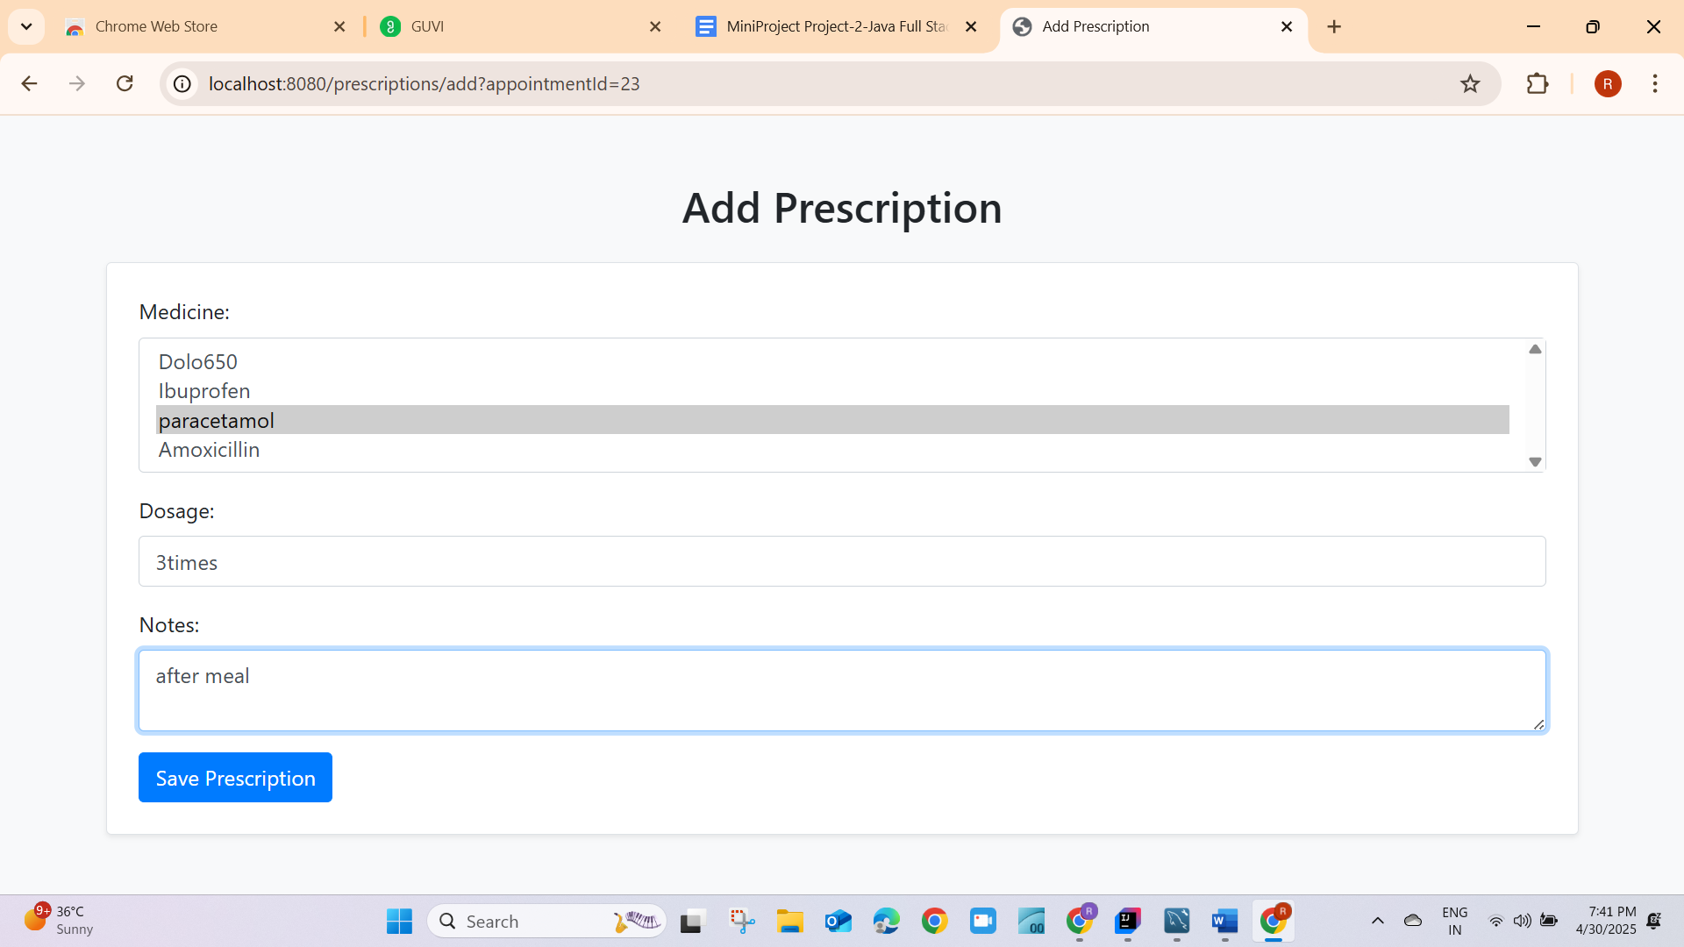

->Then give medicine name,Dosage,Notes it will give Add Prescription,and save it.

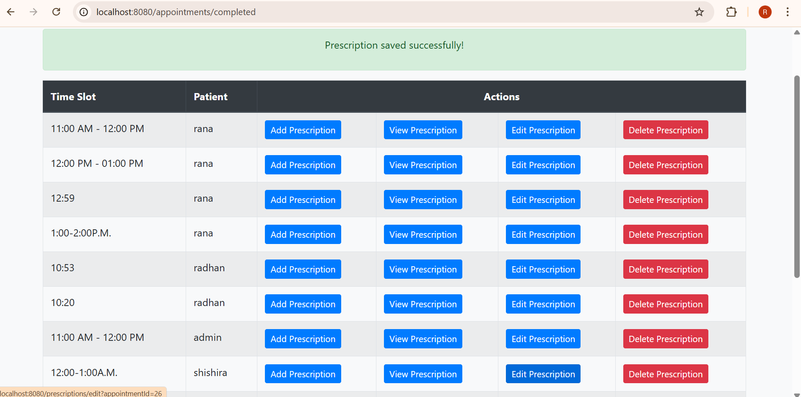

->click on ViewPrescription to view the prescription.

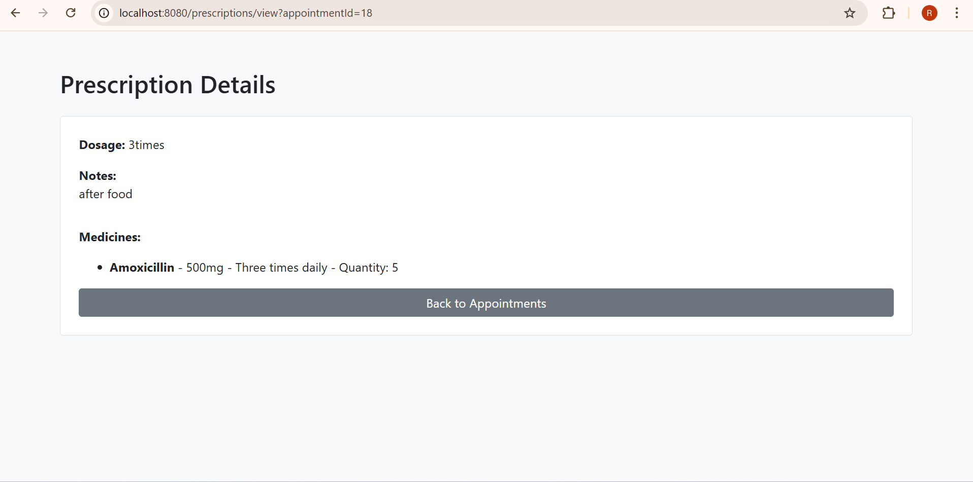

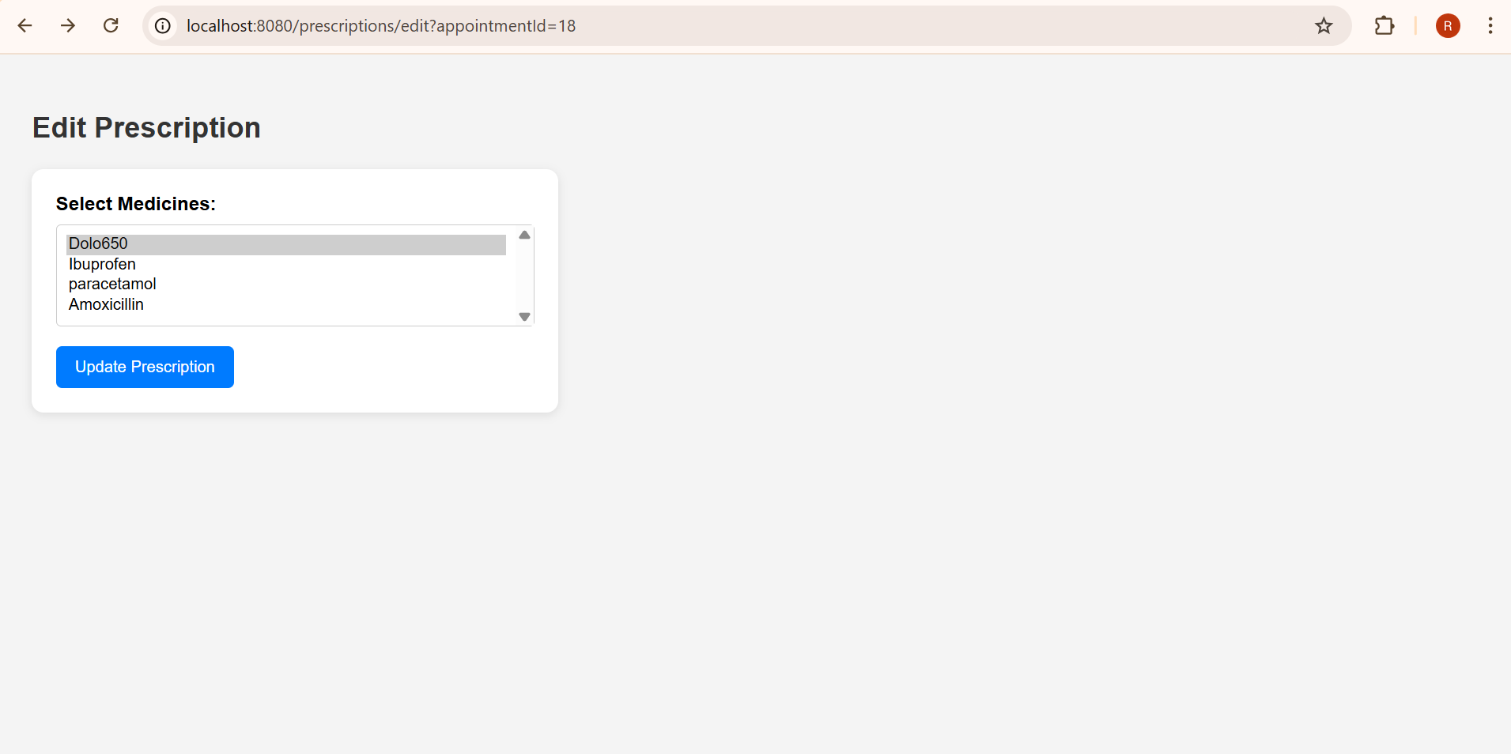

->for Edit the prescription Add the modification then click on update.

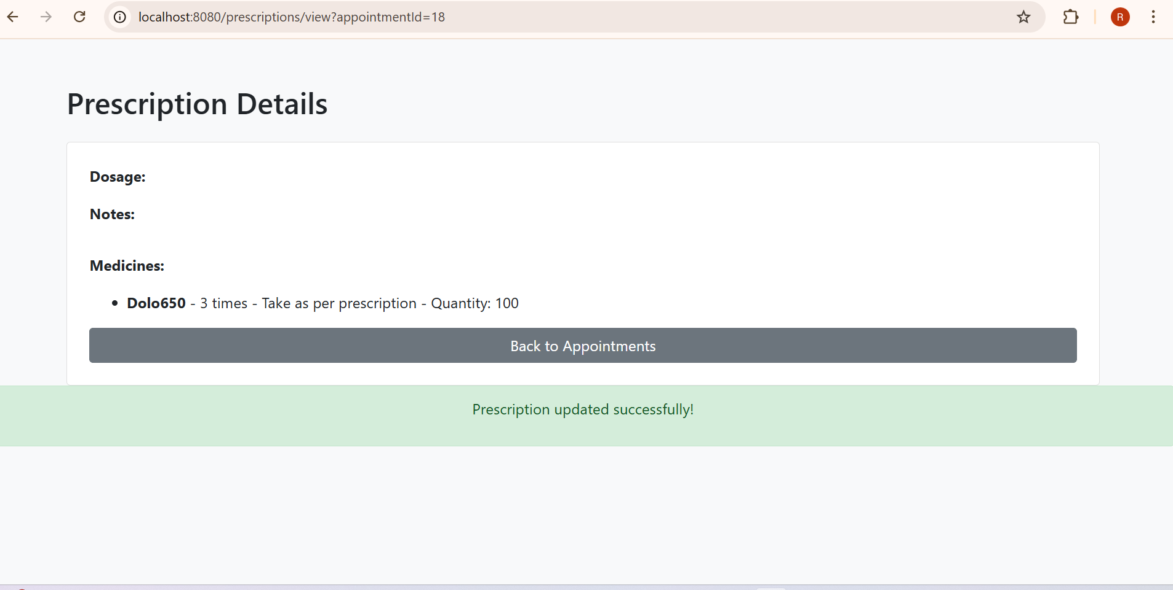

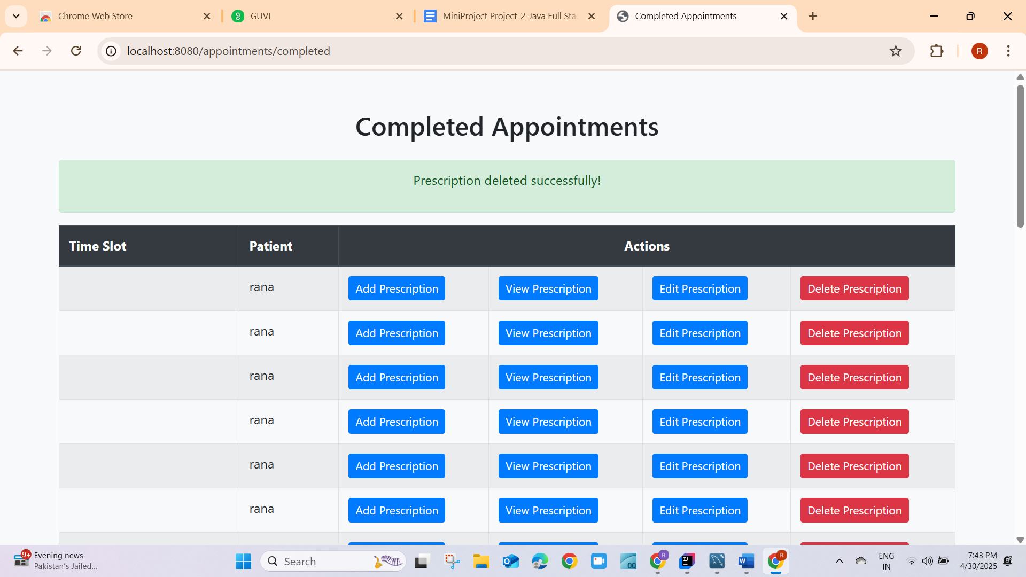

->for deleting the prescription click on delete.

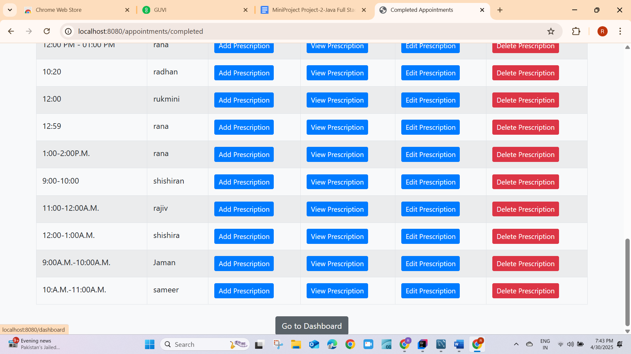

->Now click on Dashboard  
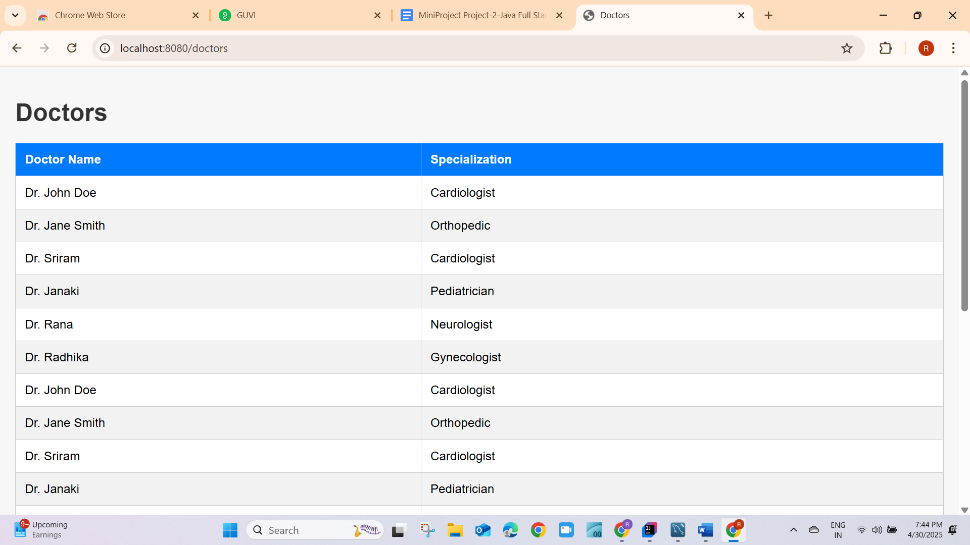

->click on manage Doctors in the DashBoard to see the information about Doctors.

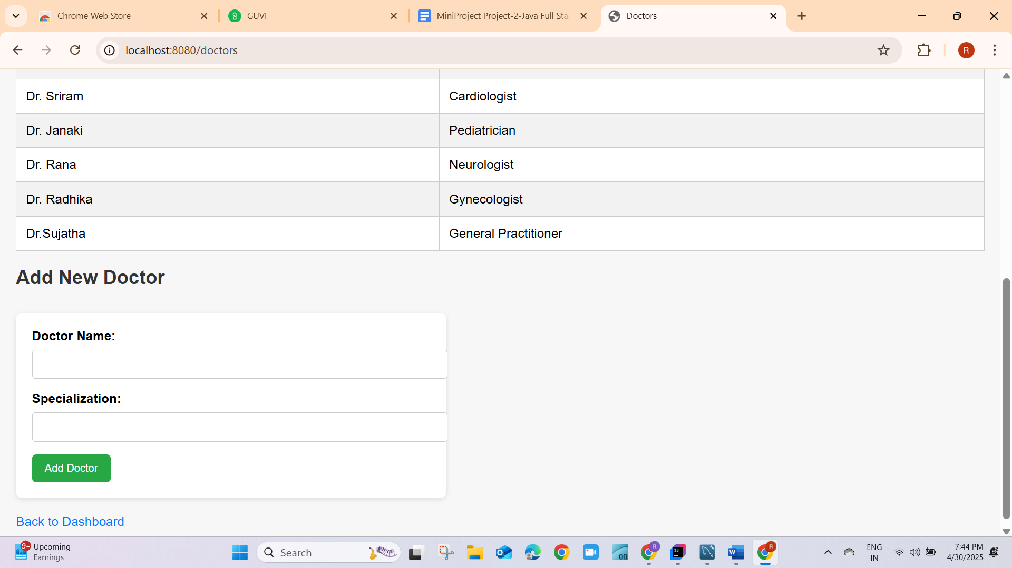

-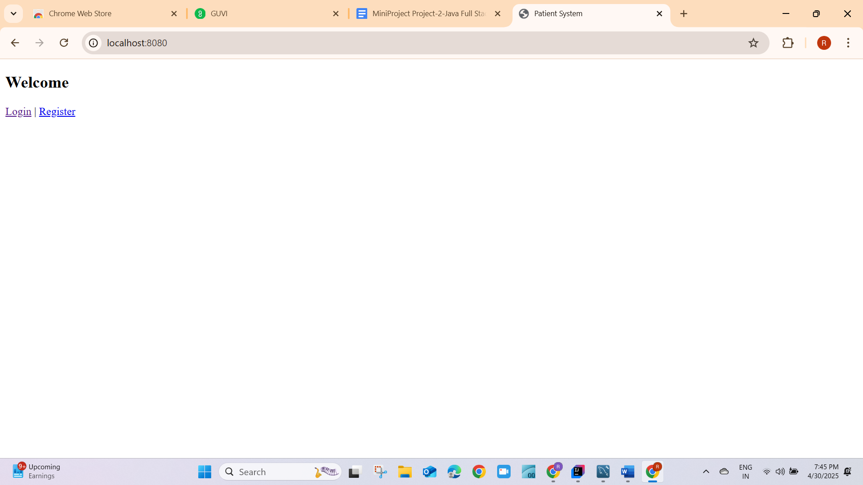

->Register and login of Authenticated Users.

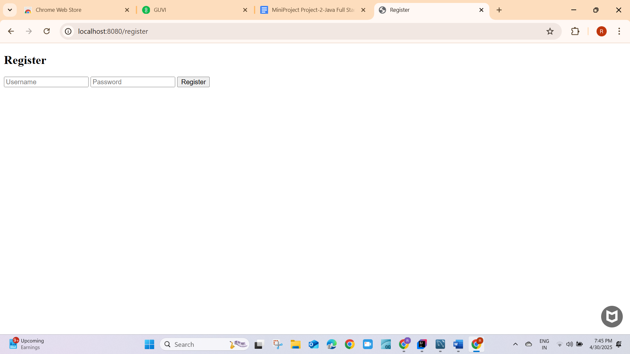

-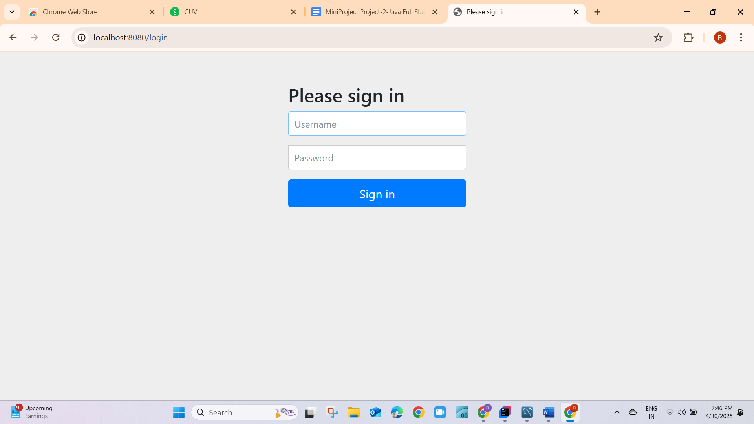

->login of Authorized users.

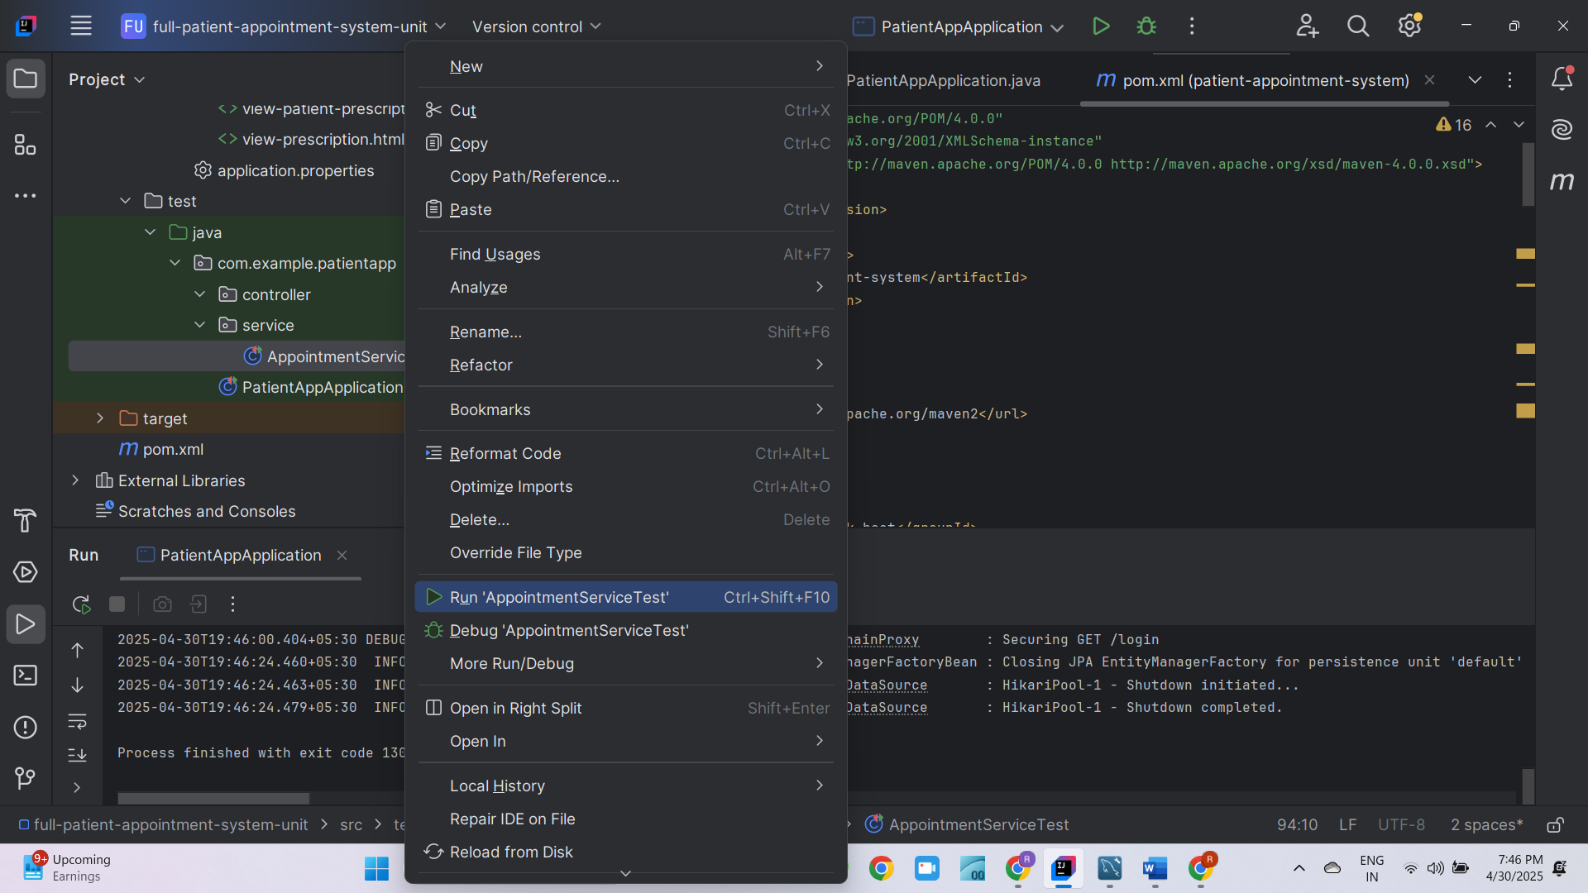

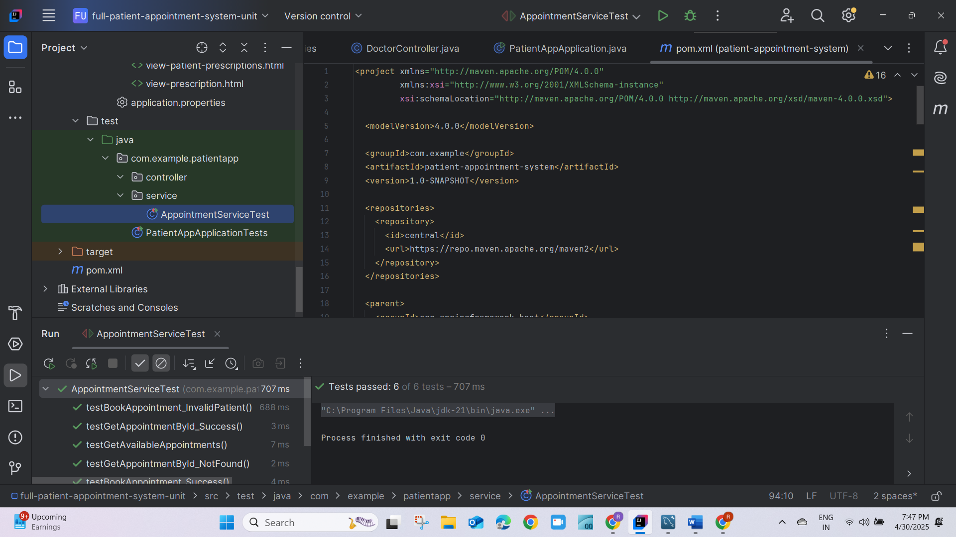

->To run the unit Test Cases in Appointment Service.passed6/6

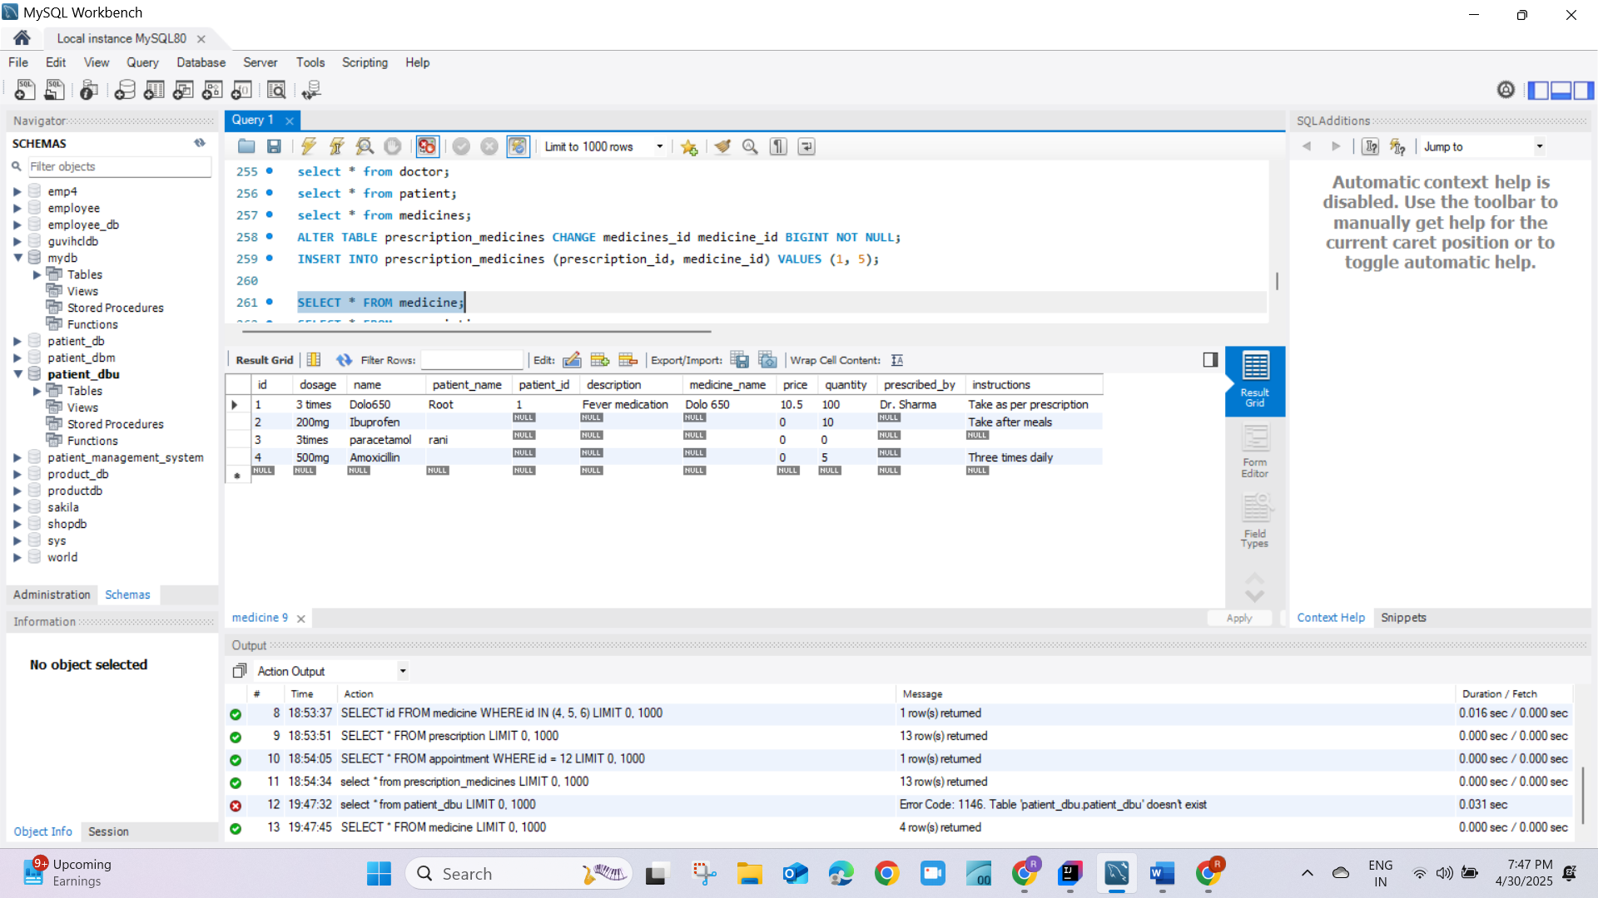

Medicine Table

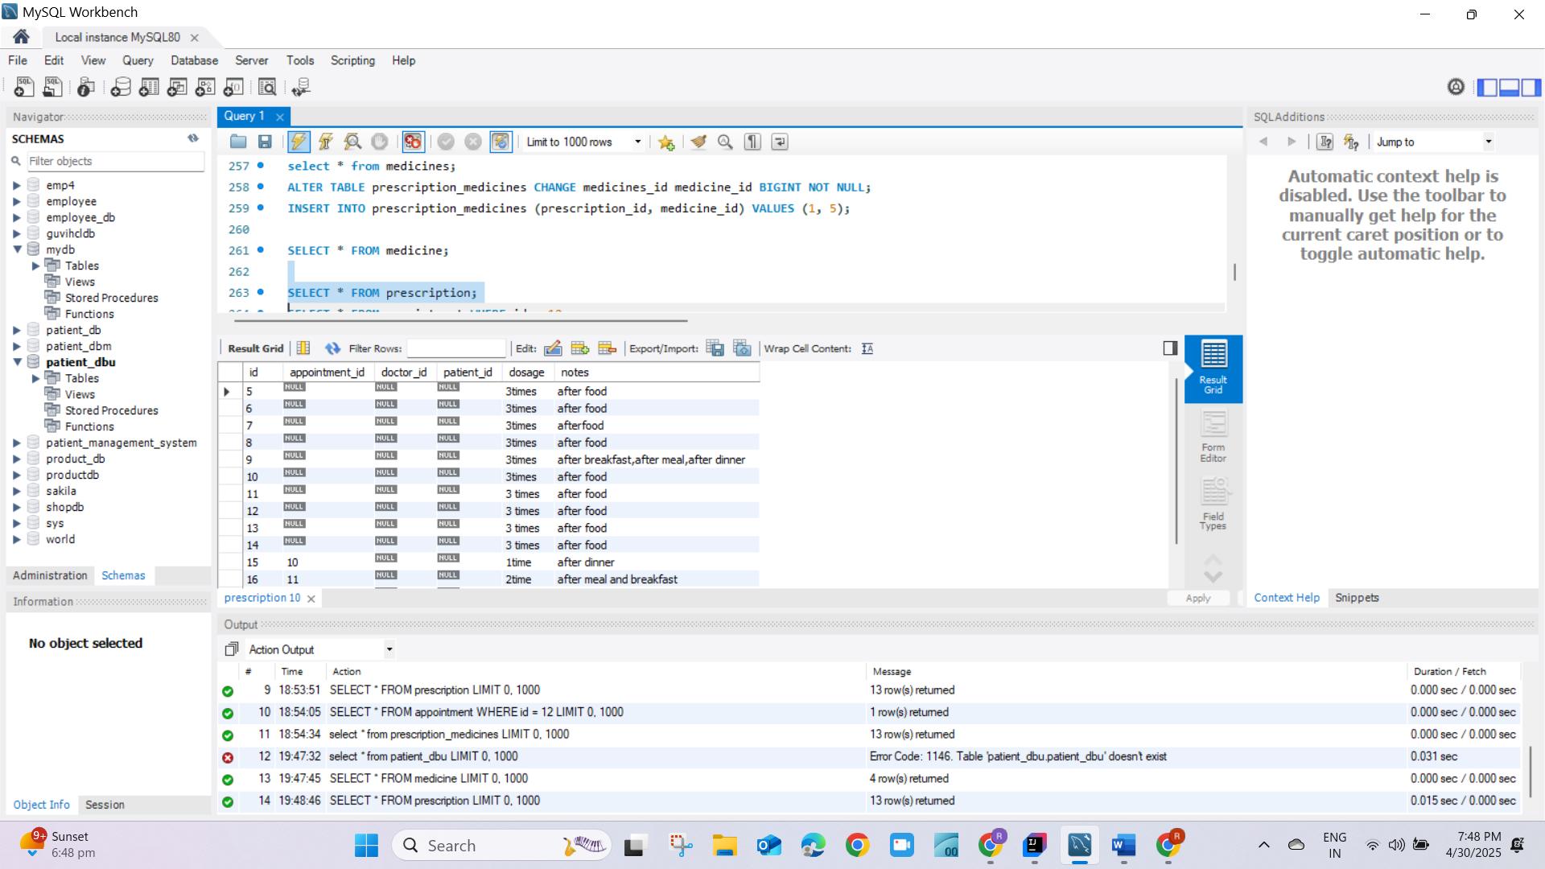

Prescription Table

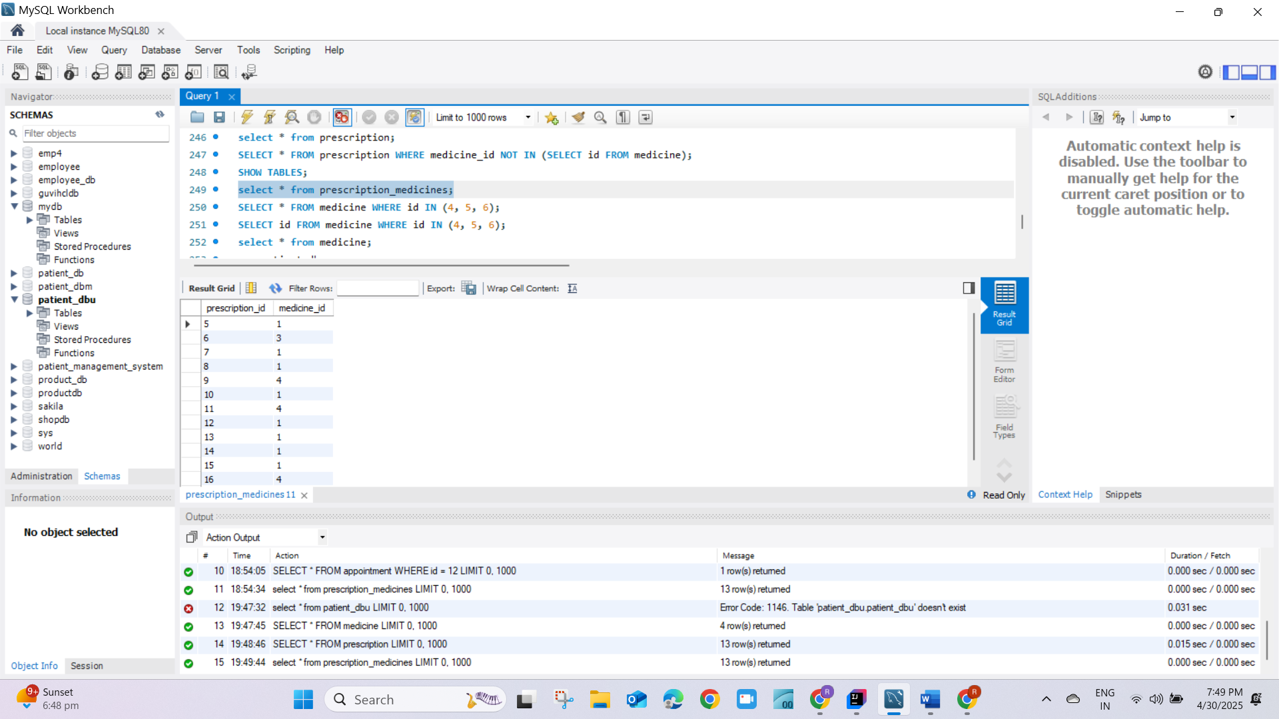

Prescription_medicine

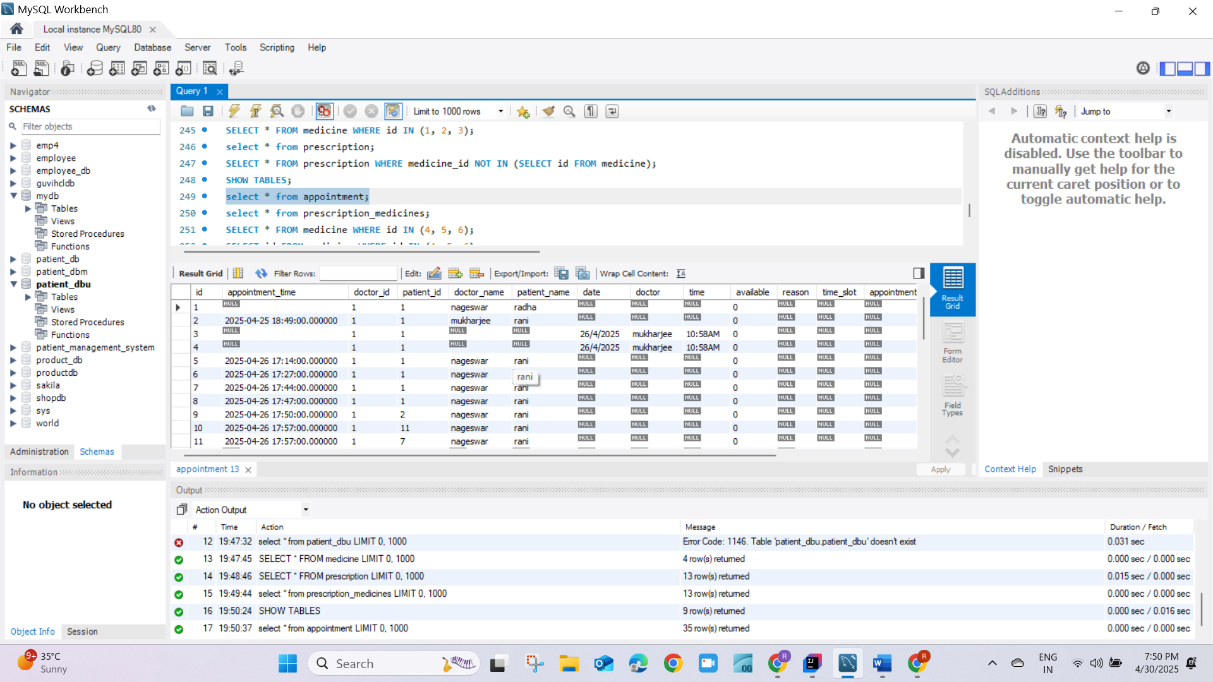

Appointments Table

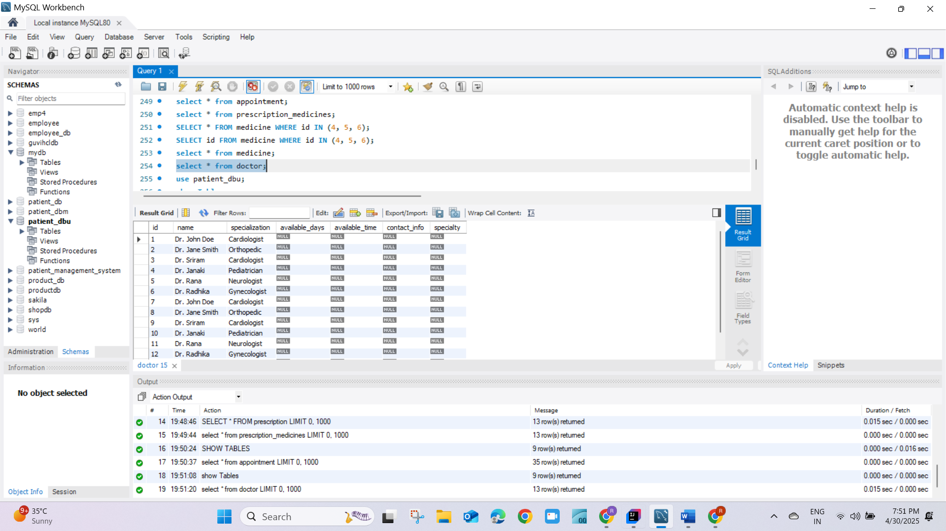

Doctor Table

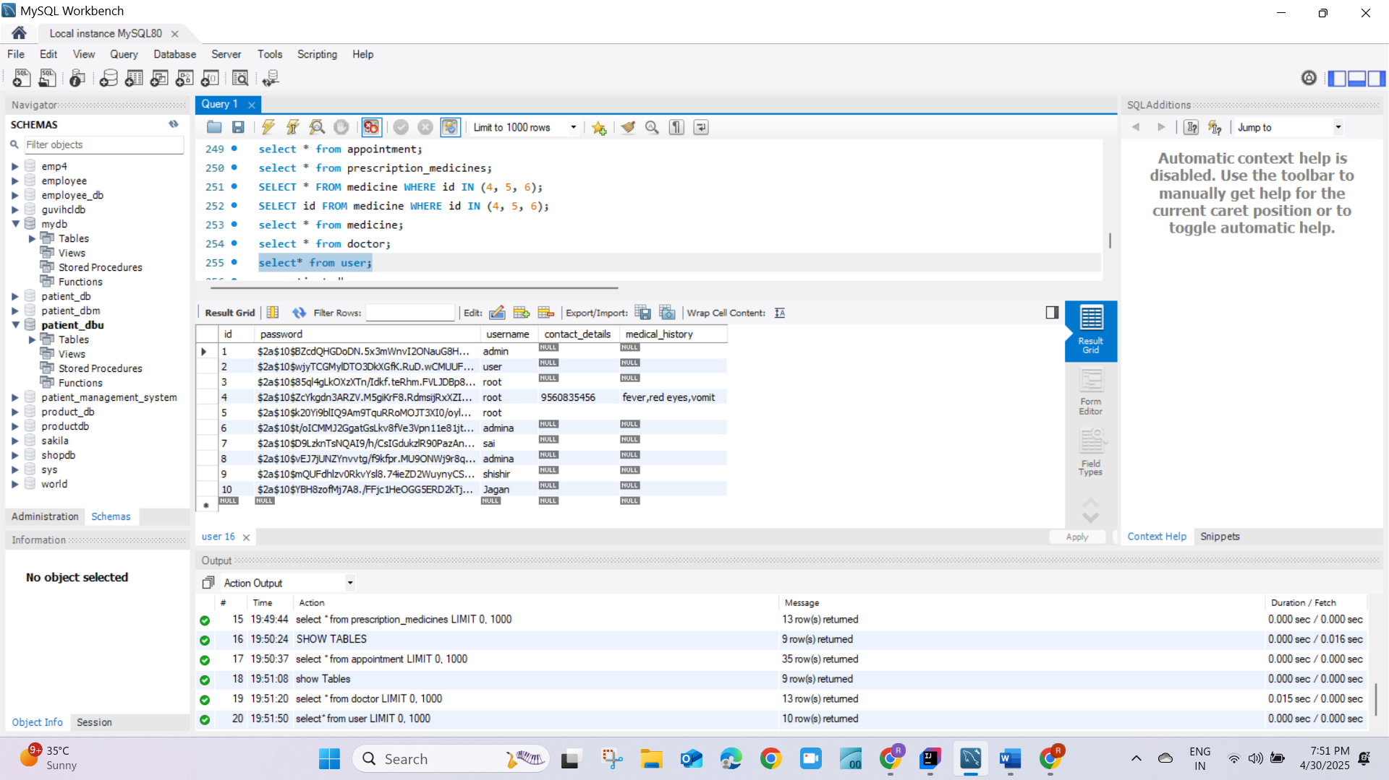

User Table.

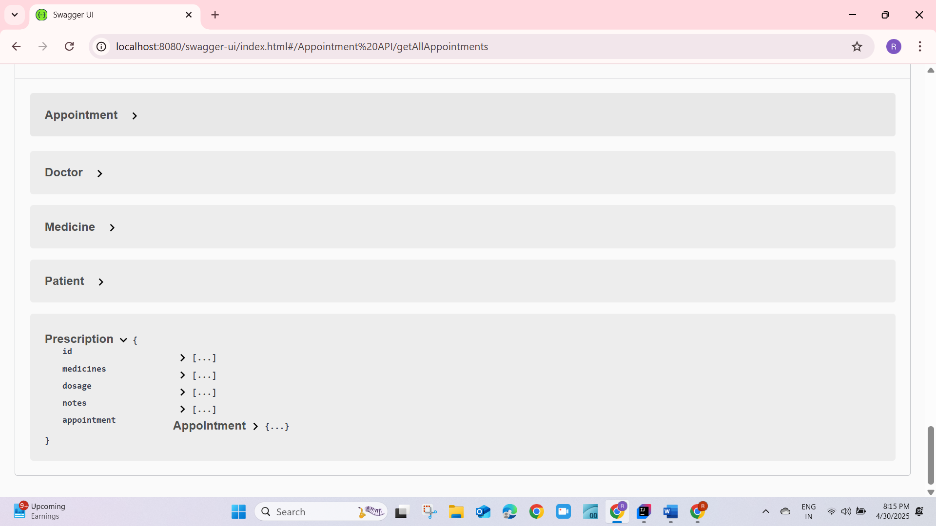

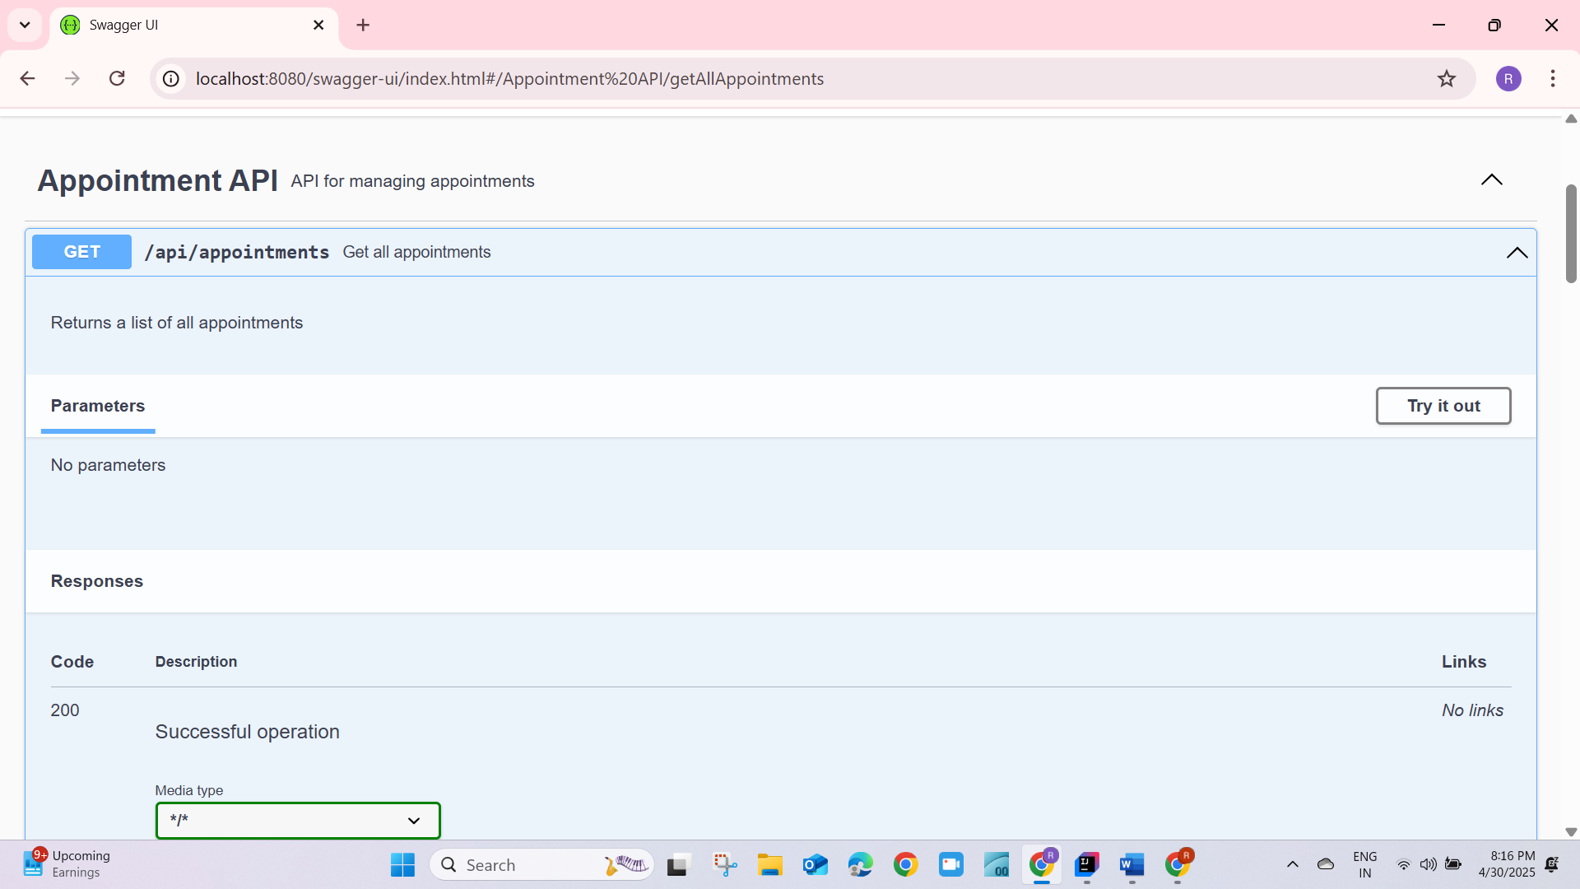

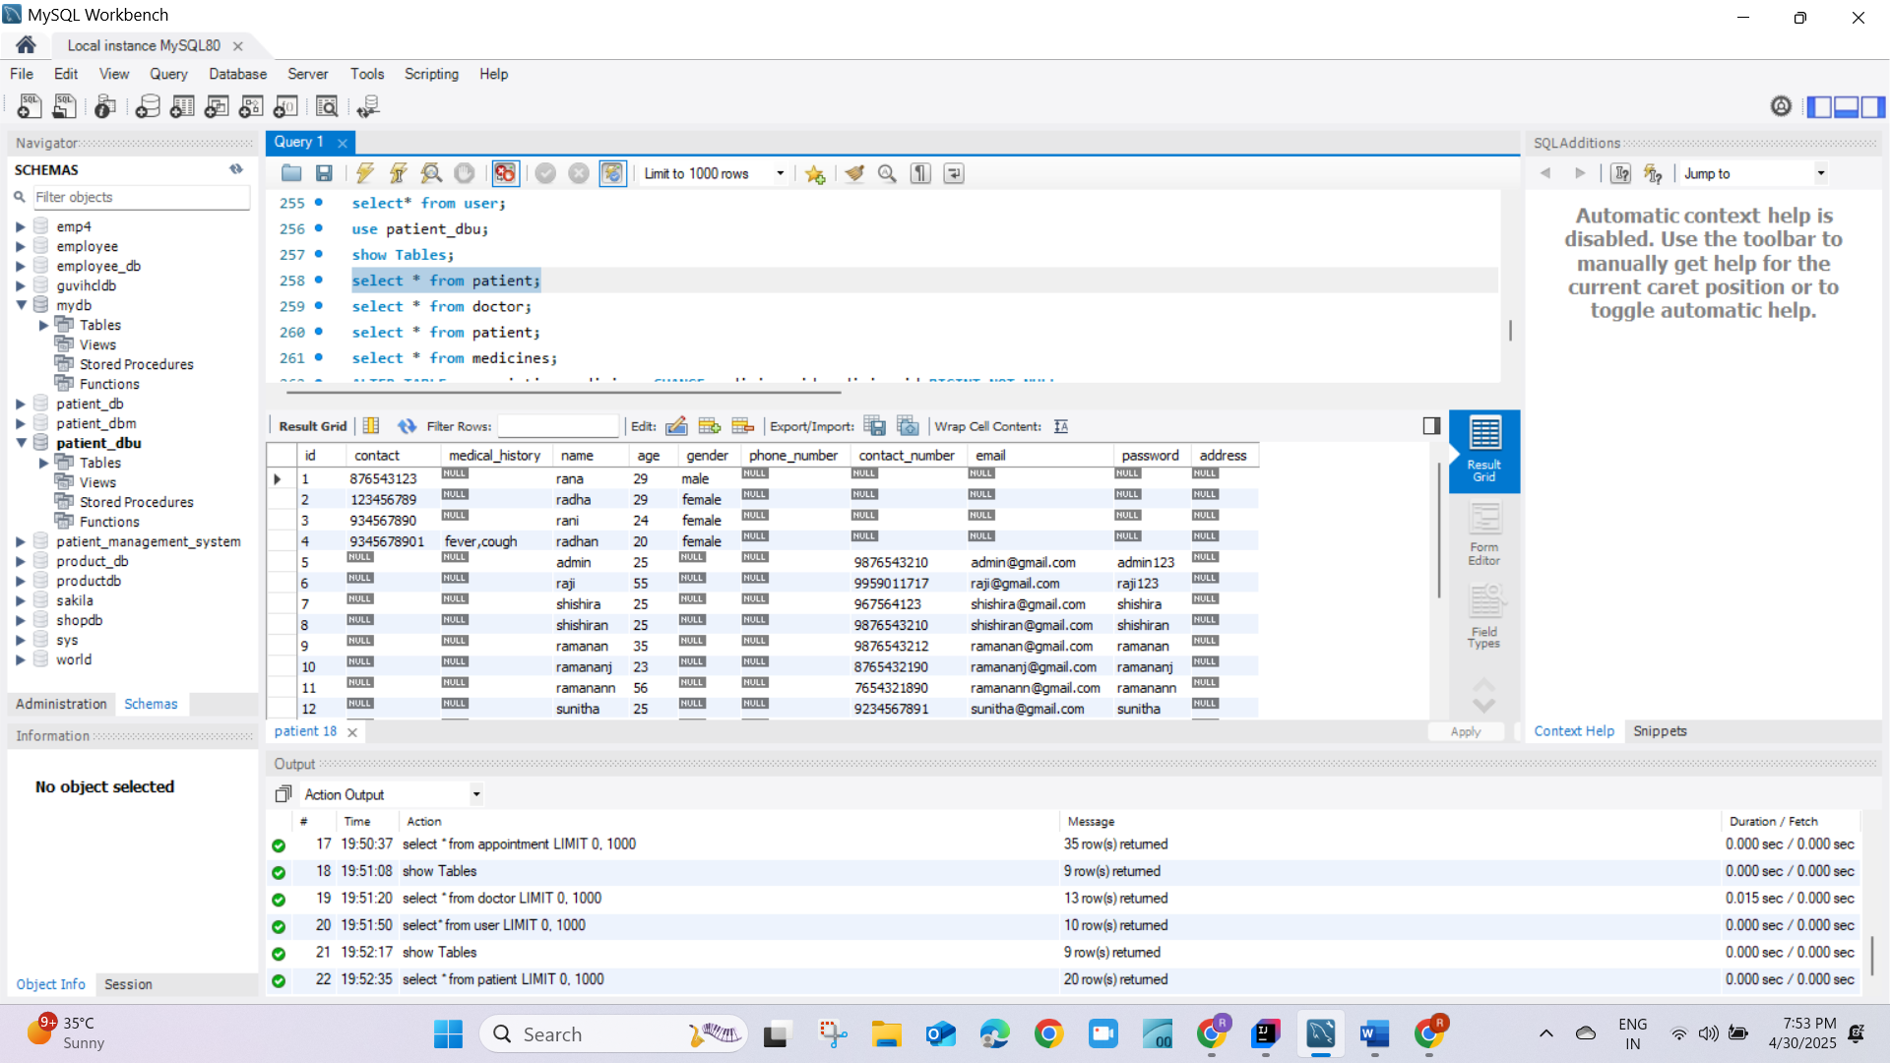

Patient Table.